Colonial Arts and Virtues
1700-1776

Colonial Wars Scholarship Award Competition
Zhanrui Kuang

March 5, 2007
Colonial Arts and Virtues (1700-1776)

It was the grand age of the Enlightenment and the Great Awakening, of the real and the ideal, of ostentation and republics, of wealth and poverty and the in between. The eighteenth century was the century of a newly prosperous and self-assured merchant middle class in both England and America. The philosophy and morality of the thinking man met in the ideals of honor, chastity, and nobility of character. The artwork produced in this time period presented the paths of vice and virtue, with a focus of the foolishness of immorality and the integrity of good faith as the populace struggled to uphold the Bible and reason. Trusting heart and conscience, many people, artists in particular, challenged the social evils around them and created visions of the ideal honorable man.
William Hogarth was an artist who grew up in England witnessing the rapid emergence of a dominating materialist culture which rebelled against Puritanical religiosity. As a result, the political corruption, sexual immorality, and human depravity that became prevalent in society encouraged Hogarth’s satirical productions. Ironically, “it was an inescapable fact that a society founded on the values of liberty stood constantly on the verge of degenerat(ion)” and utter licentiousness (Craske 12). Hogarth became highly successful for his humorous prints satirizing high society’s susceptibility to moral foibles.
Hogarth’s independent spirit reflected his broader political and religious ideology. Hogarth, along with the leading intellectuals of his time, was an iconoclastic Protestant who fought against Catholic idolatry and Calvinist predestination. In his artwork, Hogarth presented his characters as having freedom of choice. His six-panel print series, the Marriage a-la-Mode (1745), demonstrates this ideology. The story begins in the mansion of an Earl who is scheming to scramble atop the social ladder by marrying his idle son to the daughter of a wealthy merchant. The marriage is an unfortunate disaster which ends with the murder of the son and the suicide of the daughter. Hogarth’s own moral views permeate through the portrayal of the Earl’s plans as a fool’s errand.
A crucial panel from the Marriage a-la-Mode is the Breakfast Scene. In this piece, both wife and husband appear exhausted and slumped in their seats. The overturned chair and the instrument lying on the floor suggest that the wife had spent the night entertaining and playing cards. A woman’s lacy cap emerging from the husband’s coat pocket implies that he had been out trysting with a lady of dubious character. The bulky bust and overcrowded statuettes on the mantelpiece that block the painting on the wall reveal the unsophisticated tastes of a nascent middle class too eager to boast: showy, gaudy, and superficial. Hogarth intentionally used multiple flashy colors and a complex composition to emphasize his mockery of this morally depraved society. A comical scene is illustrated as the steward, with one hand full of bills, flings up the other to the heavens, as if sighing in despair, “I have given up!” The artist uses humor to communicate the foolishness of the reckless lifestyle and the dangers of living for ephemeral earthly pleasures.
While some artists satirized human degeneration, other artists elevated human dignity. Thomas Gainsborough was one of the latter. Gainsborough, as a leading practitioner of “Grand Manner portraiture,” learned to elevate his “sitter by conveying refinement and grace” (Kleiner and Mamiya 845). This idealized composure was not necessarily exuded by the client, since many portraits were of small children. Master John Heathcote, created in 1771, is an example of this. A four or five year old boy typically would not compose himself with such assurance and calm. Instead of standing still for his portrait to be painted, he probably would have been visibly impatient to go back to his playing. Here, as in so many other paintings of this time, there is a connection to the contemporary “ideal” virtues. The painting emphasizes the concept of “nobility” not as a result of aristocratic birth but of a praiseworthy character. Despite the fact that the young master’s parents were aristocrats, his material wealth is barely depicted. Even though the little boy wears imported lace, a subtle attribution to his status, he stands in a pose of sweet humility devoid of regality in front of a muted background. He clasps in his hand a little flower, symbolizing his innocence. Gainsborough underscores not the noble birth of his young client, but his pure and noble character.
The American artist Benjamin West knew and admired the work of the British painter Gainsborough. The artwork of England and its colonies were closely intertwined. English artists immigrated to the New World while American artists departed for England. Benjamin West, upon journeying to England to study art, became an official painter for King George III and proceeded to found the Royal Academy of Arts. He remained popular with the court even through the strained period of the American Revolution. Unlike Gainsborough, West was more interested in painting dramatic scenes from history. The Death of General Wolfe, created in 1771, was one such historical narrative. General Wolfe was an English commander who became a national hero after defeating the French in the decisive battle of Quebec, which turned the tide of the Seven Years War. Regrettably, the young general did not live to see the impact of his achievement. In the painting, West depicts Wolfe at his dying moment, as the light is about to leave his heavenward eyes. As a Quaker, West often imbued his paintings with religious meaning. The hero lies in the arms of his grieved compatriots in a way that imitates the death of a saint. The composition reminds viewers of scenes from Christ’s suffering—the Crucifixion, Deposition, and Lamentation. Wolfe has just been martyred for the noble cause of his country. The virtues of “courage and resolution, patriotism, and self sacrifice” depicted here are synonymous with the morals upheld during this period (Kleiner and Mamiya 846). In The Death of General Wolfe, a bleak sky revolves above the heads of the loyal patriots, who look towards the fallen general with hope and then despair. An Indian appears to be contemplating the significance of what he is witnessing, and a soldier is praying for the swift departure of his commander’s soul, in order that his worldly sufferings may end. West was interested in creating a solemn mood and producing art that comprehended both the spiritual as well as the physical life.
Like West, another expatriate who joined the influential Royal Academy was John Singleton Copley. Copley was perhaps the foremost portraitist in colonial America. Like William Hogarth, he was born of humble origins, self-taught, and prospered from his trade. Copley equated luxury goods with the character and social status of his British sitters, who wanted to avoid ostentation, but at the same time display enough to entail prosperity. Yet for his colonial subjects, Copley’s portraits were of a distinctive American style: plain, clear, and informative. Perhaps his American clients requested this, because it displayed a new kind of virtue, one crafted from the anti-materialist, Republican ideals of frugality and simplicity. Although Copley also ennobled his sitters with his brushstroke, the elevation of dignity lay not in refinement or grace, rather, in intelligence and authority. In the Portrait of Paul Revere, painted in the late 1760’s before the famous “midnight ride,” Revere is shown as a serious and contemplative intellectual. The composition is stringent, the props are simple, and the workman’s ethics are stressed. Revere’s face emerges from blackness into an almost spiritual light. The polished teapot and tabletop give off reflections, as if revealing the innermost qualities of the human mind. The details in the white shirt sleeves are meticulously delineated, and surprisingly, Revere is depicted without his gentleman’s coat. Only wealthy men and women could afford to have their likenesses painted, and as a result men were always presented in their bureaucratic coats and women in their furs and fine gowns. Yet Revere here is depicted as a workman; his wealth and the success of his business are hardly suggested, except perhaps by the barely visible gold buttons on his vest. The focus of the painting becomes the fiercely intellectual mind behind the direct and unflinching man. The emphasis is on the character, not on wealth or class. Like many other artists, Copley used his artwork to express the imperative virtues of his time, particularly humility and the authority of the thinking man.
Between the years 1700 and 1776, several core legacies were established in the art arena. As artists began to turn from ostentatious and unrestrained display to a different kind of decency, a new vision of the ideal was beginning to form. With the rise of a fresh class of moneyed clients, artists forged a style and sophistication unique to the tastes of the age. Upholding honesty and virtue, many united in the foundation of a new style that first elevated the character to the preeminence previously held only by social status. Art was the tool which unveiled the core virtues of the Enlightenment and the morals of the Great Awakening within society.
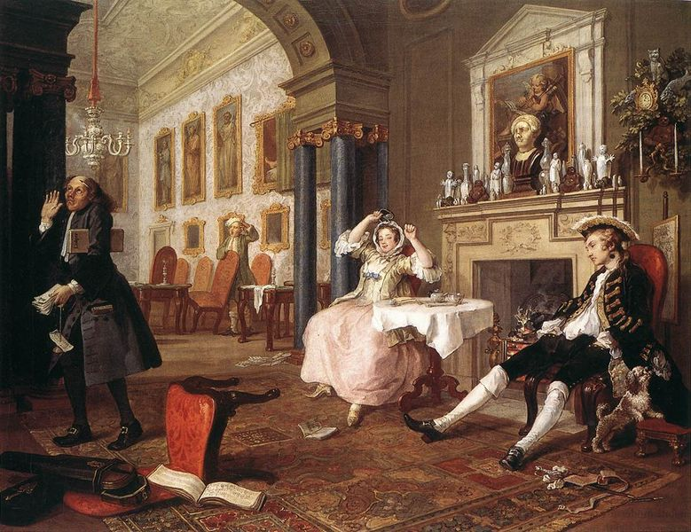

The Breakfast Scene by William Hogarth
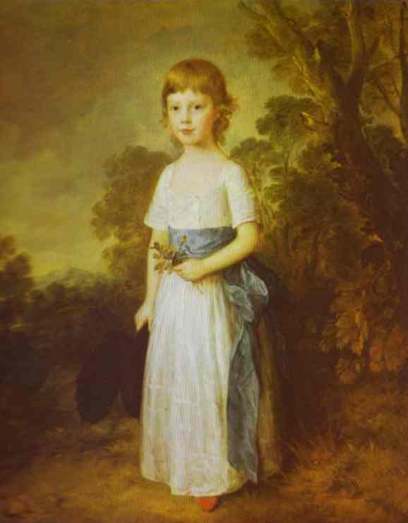

Master John Heathcote by Thomas Gainsborough
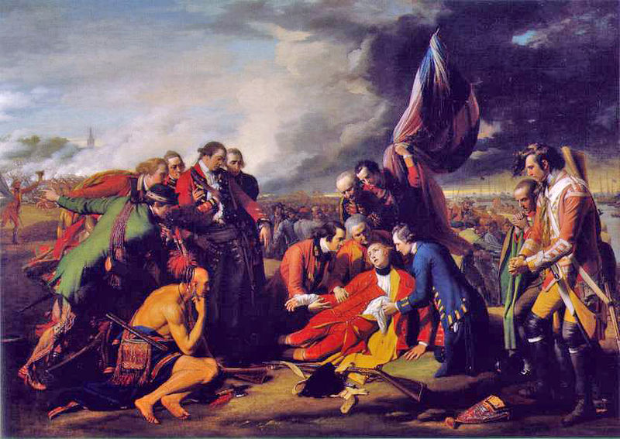

The Death of General Wolfe by Benjamin West
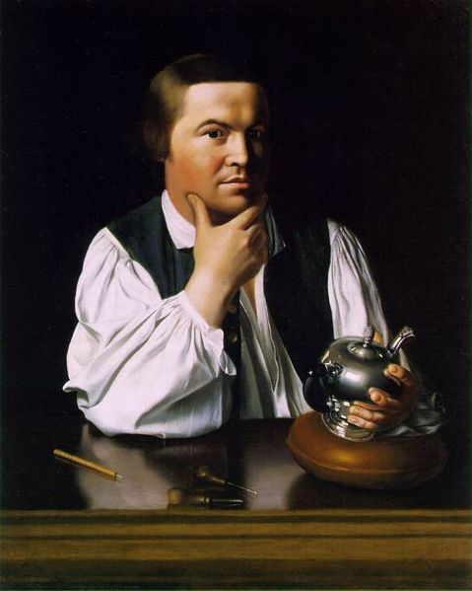

Portrait of Paul Revere by John Singleton Copley
Bibliography

Craske, Matthew. William Hogarth. Princeton, NJ: Princeton University Press, 2000.

Doezema, Marianne, and Elizabeth Milroy, ed. Reading American Art. New Haven: Yale University Press, 1998.

“Henry Fielding.” 2007. 2 Mar. 2007. <http://www.infoplease.com/ce6/peoplee/A0818636.html>.

Kleiner, Fred S., and Christin J. Mamiya. Gardner’s Art Through the Ages. 11th ed. Fort Worth: Harcourt College Publishers, 2001.

“Marriage a la Mode.” The National Gallery. 4 Mar. 2007. <http://www.nationalgallery.org.uk/cgi-bin/WebObjects.dll/CollectionPublisher.woa/wa/work?workNumber=NG113>.

“Master John Heathcote.” National Gallery of Art. 2007. 4 Mar. 2007. <http://www.nga.gov/collection/gallery/gg59/gg59-45804.0.html >.

Prown, Jules David. Art as Evidence. New Haven, CT: Yale University Press, 2001.

