**A COLONIAL TRILOGY**

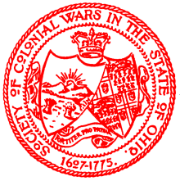

The Society of Colonial Wars in the State of Ohio

Presents

“Lord Dunmore's War”

*by*

Prof. Michael J. Voris

•

“The Colonial Colleges”

*by*

Dr. Phillip R. Shriver

•

“Howland's Relation”

*by*

Frank G. Davis, Esq.

BY WAY OF INTRODUCTION

We in the Ohio Society have been too long remiss in the publication of the many talks we have been privileged to hear at our Courts. To help right this wrong we offer you "A Colonial Trilogy".

In 1969 Nathaniel Claiborne Hale, past Governor General, noted historian and - above all - friend wrote in The Gazette, "It was the Colonial Americans who created this American Way of Life; and it is to the perpetuation of the memory of these men and the historic events in which they participated that we are dedicated. The Founders of our Society and their successors in office have all agreed that in this way we can best call public attention to the value of our heritage and thereby insure its preservation."

Further, it was James Anderson who once wrote, "There is nothing that solidifies and strengthens a nation like reading the nation's history."

We take great pride in submitting the following papers.

Richard Thayer, Editor