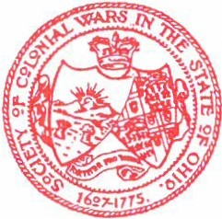

# ®rorgr §ranklin Wrlsb l)eputp ®obrmor rneral

'aebe ocietp of <tL:olonial Wars

# in tbr late of ®bio

®ffict of tbt :mepulp obrrnor rneral

6200 ltfriff er oab el:iminnati, ®bio 45242

(513) 793-0302

§ax:*(*513) 793-0312

August 2001

Dear Warrior,

I am enclosing a copy of our publication , *A Colonial Trilogy,* for your use as you see fit. The *Colonial Trilogy* has been published seven times over the past three decades and combines the writing and presentations of our Winter Court, and on occasion, Summer Court, speakers. Frank Gorman Davis, JD, Esq. has produced this labor oflove for three decades.

Editor Frank Davis graduated from Walnut Hills High School in 1935 and from the University of Cincinnati in 1939. He obtained a law degree in 1942 and served in World War II as an air traffic controller for fighter-bombers on the island of Attu for two and one­ quarter years from 1942 to 1945. He continued service in the Army Air Corps and the Air

National Guard from 1947 to 1950 and was active Air Force duty from 1950 to 1951 during the Korean War. He has been in the private practice of law from 1942 to the present.

Previous writings include papers on his forbearers, John Howland and Captain John Gorman, as weii as an articie, ''Mark Twain and Joan of Arc: Maid from Orleans and the Man from Missouri."

John K. Alexander, professor of history at the University of Cincinnati, holds a B. S.

in education degree from western Oregon State and an M.A. (1965) and a Ph.D. (1973) in history from the University of Chicago. The recipient of many teaching awards, professor Alexander has taught courses in U.S. History, Colonial-Revolutionary America, Poverty in Colonial America, Crowd Violence is Early America, Constitutional History, and Film and the American Revolution, among others. He is the author of innumerablejournal articles, book chapters, and essays about the formative years of our country. In 1999, the Tri-State Association of the Society of the Cincinnati made him its George Washington Distinguished

Professor. Professor Alexander presented his paper in the edition of the trilogy as speaker for the Saturday Luncheon of the General Society of Colonial Wars General Council meeting, held in Cincinnati, Ohio, May 12, 2000.

Pierson R. Davis, Frank's brother, also a graduate of Walnut Hills High School, was graduated from the University of Cincinnati with a B.S. in architecture. He served on active duty with the U. S. Army Corps of Engineers from 1942 to 1946, seeing action in the Asian Pacific theater and the Southwest Pacific. He has been engaged in the practice of

architecture and construction design from 1948 to the present. Pierson Davis has pursued his interests in history in the region around Beaufort, South Carolina. He visited the monument to Jean Ribault and the attempted Huguenot settlement on Parris Island . He spoke with the archeological team from the University of South Carolina, conducting a dig on that site, which developed into research on what proved to be more of a Spanish settlement. The

result of his investigations is the subject for an article in this trilogy.

Our final author is Fredrick C. Hirons, who writes on the activities of the Society of the Cincinnati in this issue. Fred Hirons, also a member of the Society of Colonial Wars, was educated at Groton and Yale, and has a master's in financial services from American University. He served in World War II as a Captain in the 82°d Airborne Division, seeing action in France and Germany. He formed his own company, offering employee benefits and estate planning throughout the years, and was a leading producer for the Union Central Life

Insurance Company, long headquartered in Cincinnati . He has received many awards in the insurance industry and has had a long career in community service, leading the United Fund Fine Arts Drive and serving on the Board for the Symphony, the Nature Center, Hillsdale and Country Day Schools, Miami Purchase, the Cincinnati Historical Society, the Cincinnati Yale Club, the YMCA, and Rotary .

We hope that you will enjoy these articles and will be inspired to record and

commemorate the musings of your own society members and guest speakers. By the exchange of such publications, warriors around the country can be better informed about our history and celebrate the contributions of their forbcarers.

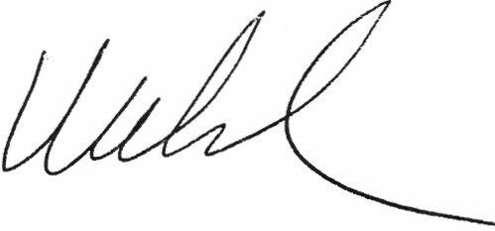

s

Frank Welsh, M.D.